

**Provisioning Template for F5 V11 to V11 Configuration Migration**

**User Guide**

|  |  |  |
| --- | --- | --- |
| **Version** | **Remarks** | **Date** |
| **1.0** | **Provisioning Template User Guide for V11 to V11 Config Migration** | **01/08/2016** |
| **2.0** | **Updated document with installation of the template.** | **14/02/2017** |
|  |  |  |
|  |  |  |

## Installation of the Template and Helper Script

1. Login to AppViewX.
2. On the left navigation menu, select ***Provisioning***; and click ***Template.***
3. On the upper right portion of the screen click on the  Import button.
4. The following screen will appear. 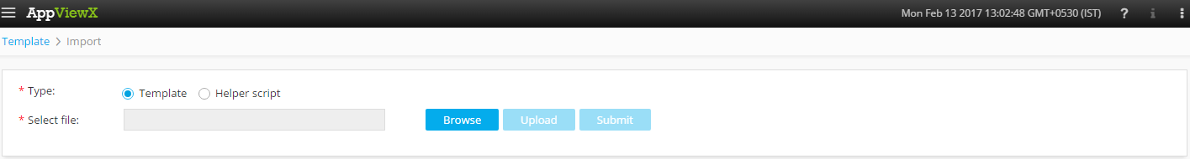
5. Please Select Template/Helper Script.  
   If Template is chosen,
   1. Click on *Browse* and select the Zip File of the template which has to be installed/imported and click open.
   2. Click on upload to import the Zip file and display the templates present in the zip file.
   3. Click on submit to deploy the templates into the AppViewX Environment.

If Helper Script is chosen,

1. Click on *Browse* and select the Zip File of the Helper script which has to be installed/imported and click open.
2. Click on upload to import the Zip file and display the Helper Scripts present in the zip file.
3. Click on submit to deploy the Helper Scripts into the AppViewX Environment.

## F5 V11 to V11 Config Migration

1. Login to AppViewX.
2. On the left navigation menu, select ***Provisioning***; and click ***Request***
3. On the upper right portion of the screen, click the  ***Create*** button.
4. Select the provisioning template name from the list – ‘**Generic_Migration_V11_V11**’

**Note:** *If no template is available, this indicates that the user role does not have permission to the requesting template.*

1. Enter the provisioning request description – ‘*Migrate configuration from V11 to V11 device* ’.
2. Add a default Request scenario name relevant to the template. ***E.g***.: V11 to V11 config migration
3. Click on  to fetch the list of F5 V11 devices in the inventory. Select the Source device from the dropdown in the **Select Source Device**field.
4. Click on  to fetch the list of *Virtual Servers* in the selected device. Select the Virtual Server from the dropdown in the **Select VS**field.
5. Click on  to fetch the *Partition, Device Name, VS Name* and *VS Existing IP* of the selected Virtual Server.
6. Enter the name of the new *virtual server* to be created in the **VS New Name** field. If no value is entered in this field, existing VS Name will be migrated to the destination device.
7. Enter the name of the new IPto be associated to the virtual server in the **VS New IP** field. If no value is entered in this field, existing VS Existing IP will be associated to the New Virtual Server on the destination device.
8. Please enter the value in the**New Description** field if required.
9. Click on  to add the *Virtual Server* in to the tabular for creation on destination device. Multiple *Virtual Servers* can be added in a similar manner to the tabular to be setup on the destination device.
10. On selecting a particular *Virtual Server* entry, click on  to modify the details. Additionally, the *Virtual Server* entry can be deleted from the tabular by selecting the specific record and clicking on.
11. Click on  in the **Associated VS** field to fetch the *Pool members* of the selected Virtual Server. The *Pool members* are populated in the tabular field if present.
12. On selecting a particular *Pool Member* entry, click on  to modify the details. Additionally, the *Pool Member* entry can be deleted from the tabular by selecting the specific record and clicking on.
13. The associated *SNAT Pools* are automatically populated in the **SNAT Pools** field.
14. Click on  in the **Select Destination** field to fetch the list of available V11 devices from the inventory. Select the *Destination device* from the destination device.
15. On the **VS_Preval** field, click on  to verify if the *Virtual Server, Pool, Profile* and *Monitors* with the same names specified for migration are already present on the destination device. If present, **VS_Preval, Pool_Preval, Profile_Preval** and **Monitor_Preval** fields are populated with the configuration information as in the figure below.

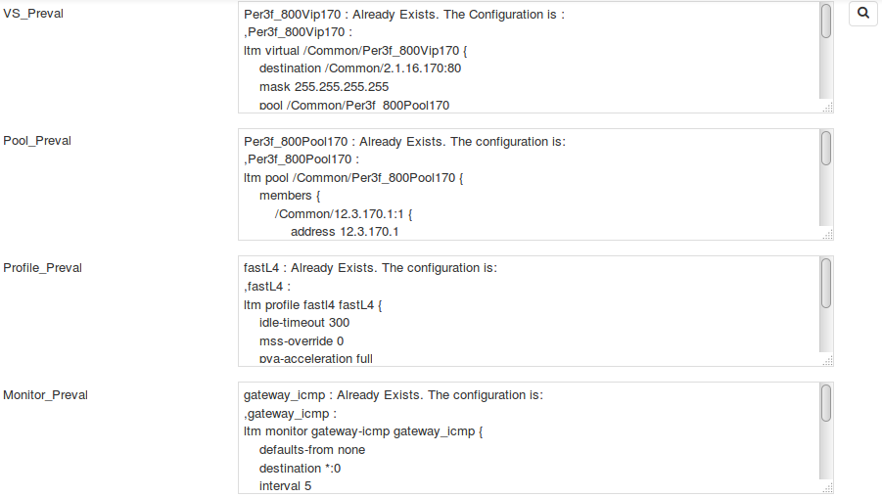

1. Click  Button; ensure that the ***Scenario*** is displayed on the right hand pane.
2. Click on ***Submit*** to generate work order(s) for the provisioning request.